
FRESH TEACHER'S E-LIBRARY
BEGINNING OF TERM III EXAMINATION 2023
PRIMARY TWO
MATHEMATICS

My name is __________________________________________

I am in ______________________________________________

My school is _________________________________________
SECTION A:
- Add: 3 + 2 = _____

- Name the set below.
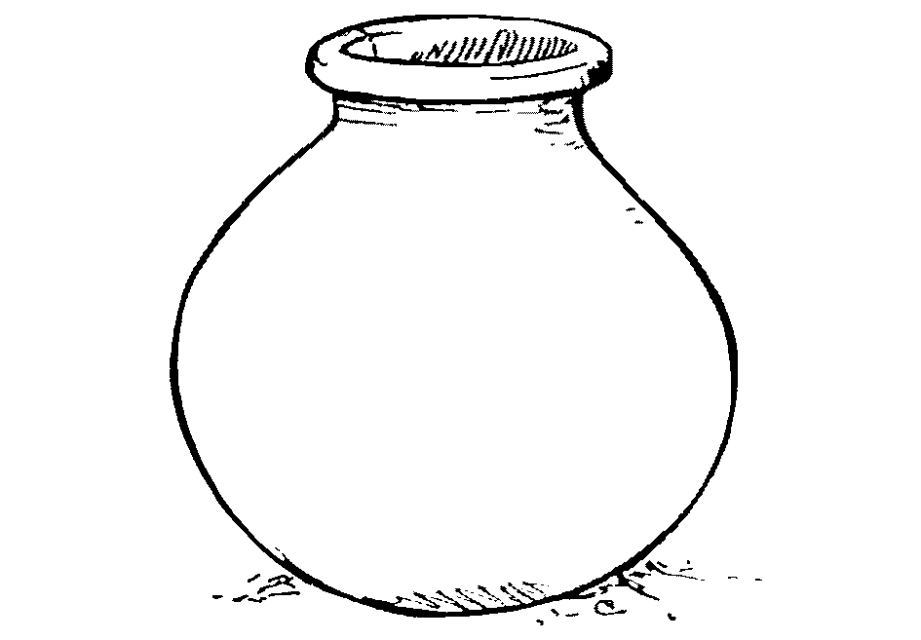
________________________________

- Draw a triangle in the space below.

- Count and write the number symbol.

= ________

- Fill in the missing numbers.
10 , 20 , 30 , 40 , _____ , 60 , 70 , 80 , 90 , _____
- Subtract: 4 9
- 3 9

- Shade  of the diagram.

- Underline the biggest amount of money.
Sh. 400 sh. 800 sh. 100

- Complete the abacus.
H T O
1 4

- A mother had 14 bananas. She shared them equally between
John and Mary. How many bananas did Mary get?

- Study the pictures.
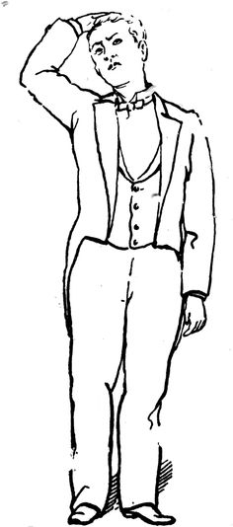
180cm
Father
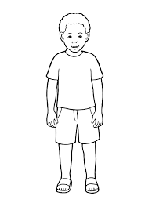
Son
100cm

The _______________ is shorter than the ________________.
SECTION B:
- The picture graph below shows pencils picked by four
children.

Karen
Mark
James
Jovia

- How many children picked pencils?
___________________________________________________________
- Who picked the highest number of pencils?
___________________________________________________________
- Who picked 3 pencils?
___________________________________________________________
- Find the total number of pencils picked by all the four
children.

___________________________________________________
- Match correctly.
 two thirds.
 a half
 a quarter
- Study the price list below.
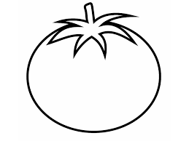
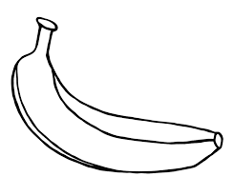

Tomato Banana Apple
Sh. 300 Sh. 300 Sh. 1000

- How many items are on the list?
_______________________________________________________
- Which two items cost sh. 300?
_______________________________________________________
- What is the most expensive item on the list?
_______________________________________________________
- Find the total cost of a tomato and an apple.

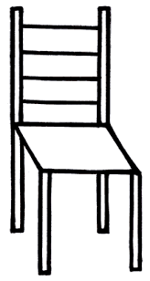
____________________________________________________
L
M
- Set Set

- Which set has more members?
______________________________________________________
- Which set has fewer members?
_______________________________________________________
- How many members do the two sets have altogether?

______________________________________________________
***************** END ******************

